Yapham cum Meltonby Parish Council

[www.yaphamcummeltonby.co.uk](http://www.yaphamcummeltonby.co.uk)

Clerk : Mrs Jo Green, 29 Barmby Road, Pocklington, York YO42 2DL Tel.01759 301386

Dear Councillor

A meeting of Yapham cum Meltonby Parish Council will be held on **Tuesday 1st December 2015** in the **Village Hall, Yapham at 7.30pm**. You are summoned to attend, if you are unable to attend, please contact me in order that I can record your apologies.

Members of the public are welcome to attend the meeting and may address the council during the Public Participation period. An agenda for the meeting is shown below.

Yours sincerely,

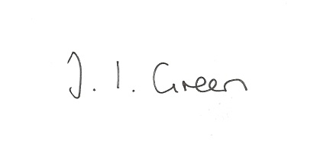Joanna Green, clerk of the council. 24/11/15

AGENDA

**Welcome**

**Public Session**. Helen Reynolds, Rural Community Transport Officer will address the meeting and explain how to identify unmet transport needs in the parish.

**120/15 Apologies.**

**121/15 To receive Declarations of Interest.**

**122/15 To adopt the minutes of meetings held on 10th November 2015 as a true record**

**123/15 To receive the clerk's report on matters being progressed from previous meetings.**

Electronic working with the planning service

Planning matters

Public Transport

Neighbourhood Watch

Data Protection

**124/15** **To determine the precept for 2015/16**

**125/15 To consider what action, if any should be taken regarding the fallen tree at the allotments**

**126/15 Accounts**

Bank balance £

To consider continued contribution to the clerk's membership of the Society of Local Council Clerks

To approve the payments below:

ERNLLCA -clerk's training course £22.00

Zurich -insurance £

**127/15 Correspondence**

ERYC consultation re changes to Dog Control orders etc

ERYC review of winter services policy

ERYC re issues arising from Walkabout.

**128/15 Councillors reports**

**129/15 Date of next meeting and meeting dates for 2016**