Yapham cum Meltonby Parish Council

[www.yaphamcummeltonby.co.uk](http://www.yaphamcummeltonby.co.uk)

Clerk : Mrs Jo Green, 29 Barmby Road, Pocklington, York YO42 2DL Tel.01759 301386

Dear Councillor

A meeting of Yapham cum Meltonby Parish Council will be held on **Tuesday 9th May 2017** in the **Village Hall, Yapham at 7.30pm**. You are summoned to attend, if you are unable to attend, would you please contact me in order that I can record your apologies.

Members of the public are welcome to attend the meeting and may address the council during the Public Participation period. An agenda for the meeting is shown below.

Yours sincerely,

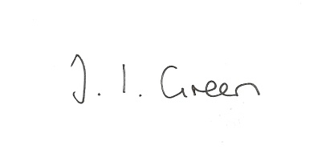

Joanna Green, clerk of the council. 4/5/17

AGENDA

**44/17 Welcome and Apologies**

**45/17 To elect officers:**

Chairman

Vice- Chairman

Representatives to other bodies

**46/17 To approve the Annual Governance Statement for 2016/17**

**47/17 to approve the accounts for 2016/17**

**48/17 to approve financial arrangements for the coming year :**

To approve the Financial Standing Orders

To appoint an internal auditor

To appoint bank signatories.

**49/17 To receive Declarations of Interest**.

**50/17 To adopt the minutes of the meeting held on 11th April 2017 as a true record**

**51/17 To receive the clerk's report on matters being progressed from previous meetings.**

Gravel Pit Field

**52/17 Planning**

To consider whether or not to support the application below:

17/01104/PLF Proposal: Erection of two storey extension to rear

Location: 4 The Square Yapham East Riding Of Yorkshire YO42 1PJ

Applicant: Mrs C Simpson Application type: Full Planning Permission

**53/17 To consider whether to apply for further Transparency Code funding**

**54/17 To consider the clerk's rate of pay**

**55/17 Accounts**

The bank balance £

To approve the payments below:

Clerk's salary April £133.81

**56/17 Correspondence**

Humberside Police newsletter

ERYC invitation to Civic Evensong

ERYC invitation to Festival of St John service

ERYC re referral of East Riding of Yorkshire Clinical Commissioning Group's decision, regarding urgent care centres and community beds, to the Secretary of State for Health

ERNLLCA being a good Councillor Training

ERNLLCA April Newsletter

National Association of Local Councils Star Councils awards

Channel 4 and Village of the Year

**57/17 Councillors reports**

**58/17 Date of next meeting**